
Tertiary Infotech Academy Pte Ltd
UEN: 201200696W
LESSON PLAN
For
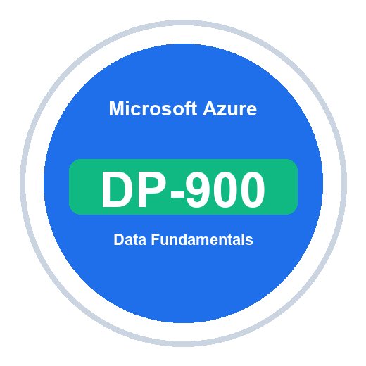
Microsoft Azure Data Fundamentals (DP-900)
TGS Ref No: TGS-2023036641
Conducted by
Tertiary Infotech Academy Pte Ltd
UEN: 201200696W
Version 1.0

DOCUMENT VERSION CONTROL RECORD
Version Number | Effective Date of Release | Summary of Included Changes | Author
1.0 | 8 July 2026 | Initial DP-900 Lesson Plan aligned to the slide map and all 10 labs. | Tertiary Infotech Academy Pte Ltd

TABLE OF CONTENTS
Course Information 4
Learning Outcomes 4
Daily Schedule 5
Day 1 5
Day 2 6
Topic-by-Topic Breakdown 7
Resources Required 8
Assessment 9
Assessment Flow 10

Course Information
Item | Details
Course Title | Microsoft Azure Data Fundamentals (DP-900)
WSQ Course Reference | TGS-2023036641
Duration | 2 days, 16 training hours
Timing | 9:00 AM-6:00 PM; assessment on Day 2 from 4:00 PM
Delivery Mode | Instructor-led, hands-on labs using Azure portal, Microsoft Learn and guided design activities
Trainer | Dr. Alfred Ang
Note: the 'Slides' column in each daily schedule references the exact slide numbers in the Learner Guide Slides deck for that activity.

Learning Outcomes
- Describe structured, semi-structured and unstructured data.
- Compare transactional and analytical workloads.
- Identify common data roles and data store options.
- Explain relational concepts, SQL, normalization and database objects.
- Describe Azure SQL and open-source database services on Azure.
- Describe Azure Storage, Azure Cosmos DB and NoSQL patterns.
- Explain ingestion, processing, analytical data stores, batch and streaming analytics.
- Describe Microsoft Fabric, Azure Databricks, real-time analytics and Power BI concepts.
- Match data scenarios to appropriate Azure data services for DP-900 exam readiness.

Daily Schedule

Day 1
Time | Duration | Topic / Activity | Method | Slides
9:00-9:30 | 30 min | Welcome, course objectives, ground rules and AM digital attendance | Briefing | -
9:30-10:40 | 70 min | Topic 1: Core Data Concepts; Lab 01 | Concept + lab | Slides 23-25
10:40-10:50 | 10 min | Tea Break | Break | -
10:50-12:15 | 85 min | Lab 02 and review of data roles, storage options and file formats | Lab | Slides 26-28
12:15-13:00 | 45 min | Topic 2: Relational data, SQL, normalization and objects | Concept | Slides 30-31
13:00-14:00 | 60 min | Lunch Break | Lunch | -
14:00-15:25 | 85 min | Lab 03: relational design and SQL concepts | Lab | Slides 33-35
15:25-15:35 | 10 min | Tea Break | Break | -
15:35-17:15 | 100 min | Lab 04: Azure SQL and open-source databases on Azure | Lab | Slides 36-38
17:15-18:00 | 45 min | Day 1 recap, checkpoint questions and PM digital attendance | Review | -
Total training time excluding lunch: 480 minutes (8 hours).

Day 2
Time | Duration | Topic / Activity | Method | Slides
9:00-9:15 | 15 min | Day 1 recap and AM digital attendance | Review | -
9:15-10:25 | 70 min | Topic 3: Non-relational data on Azure; Lab 05 | Concept + lab | Slides 43-45
10:25-10:35 | 10 min | Tea Break | Break | -
10:35-11:40 | 65 min | Lab 06: Azure Cosmos DB, NoSQL and APIs | Lab | Slides 46-48
11:40-13:00 | 80 min | Topic 4: analytics ingestion, processing and analytical stores; Lab 07 | Concept + lab | Slides 53-55
13:00-14:00 | 60 min | Lunch Break | Lunch | -
14:00-15:05 | 65 min | Lab 08: Fabric, Databricks and real-time analytics | Lab | Slides 56-58
15:05-15:15 | 10 min | Tea Break | Break | -
15:15-15:45 | 30 min | Lab 09: Power BI models and visualizations | Lab | Slides 63-65
15:45-16:00 | 15 min | Lab 10: capstone service map, cleanup and assessment briefing | Capstone | Slides 66-68
16:00-17:00 | 60 min | Written Assessment (WA), open book | Assessment | -
17:00-18:00 | 60 min | Practical Performance (PP), answer submission and PM digital attendance | Assessment | -
Total training time excluding lunch: 480 minutes (8 hours).

Topic-by-Topic Breakdown

Topic 01: Core Data Concepts (Slides 20-21)
Data types, workloads, roles, stores and file formats
- Lab 1: Core Data Concepts, Data Types, Workloads - Slides 23-25
- Lab 2: Data Roles, Storage Options, File Formats - Slides 26-28

Topic 02: Relational Data on Azure (Slides 30-31)
Relational design, SQL, Azure SQL and open-source databases
- Lab 3: Relational Data, SQL, Normalization, Database Objects - Slides 33-35
- Lab 4: Azure SQL and Open-Source Databases on Azure - Slides 36-38

Topic 03: Non-Relational Data on Azure (Slides 40-41)
Azure Storage, Blob, Files, Tables and Cosmos DB
- Lab 5: Azure Storage, Blob, Files, Tables - Slides 43-45
- Lab 6: Azure Cosmos DB, NoSQL, APIs - Slides 46-48

Topic 04: Analytics Workloads on Azure (Slides 50-51)
Ingestion, processing, analytical stores, Fabric, Databricks and real-time analytics
- Lab 7: Analytics, Ingestion, Processing, Analytical Data Stores - Slides 53-55
- Lab 8: Microsoft Fabric, Azure Databricks, Real-Time Analytics - Slides 56-58

Topic 05: Power BI and Exam Readiness (Slides 60-61)
Models, visualizations, service mapping and capstone review
- Lab 9: Power BI, Data Models, Visualizations - Slides 63-65
- Lab 10: DP-900 Capstone and Exam Readiness - Slides 66-68

Resources Required
- Azure portal
- Azure Cloud Shell
- Microsoft Learn
- Azure Data Studio
- Power BI Desktop
- DP-900 lab repository
- LMS/TMS portal

Assessment
- Day 2, 4:00 PM-5:00 PM: Written Assessment (WA), open book.
- Day 2, 5:00 PM-6:00 PM: Practical Performance (PP), open book.
- Learners must take Assessment digital attendance before starting.
- Learners submit completed answers on the LMS.
- Minimum 75% attendance is required for assessment and funding.

Assessment Flow
- TRAQOM: scan the QR code on the LMS.
- Take Assessment digital attendance.
- Complete Written Assessment and Practical Performance.
- Submit answers on the LMS.
- Sign the Assessment Summary Record.

